Exercise 11
- Count the number of employees who have been with Bignet for four or more years.
Answer: SELECT COUNT(emp_id) AS employees_4_or_more_years
FROM employee_data
WHERE years_of_service >= 4;
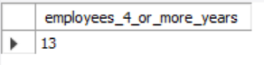

- Count employees based on their ages.
Answer: SELECT age, COUNT(emp_id) AS number_of_employees
FROM employee_data
GROUP BY age;
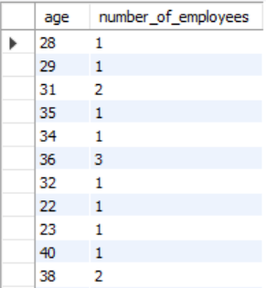

- Modify the above so that the ages are listed in a descending order.
Answer: SELECT age, COUNT(emp_id) AS number_of_employees
FROM employee_data
GROUP BY age
ORDER BY age DESC;

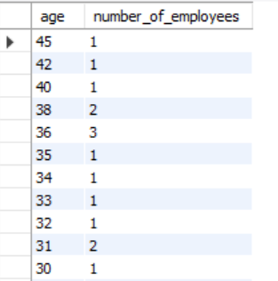

- Find the average age of employees in different departments (titles).
Answer: SELECT title, AVG(age) AS average_age
FROM employee_data
GROUP BY title;

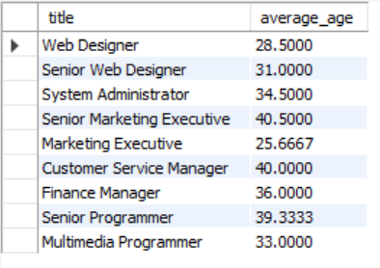

- Change the above statement so that the data is displayed in a descending order of average ages.
Answer: SELECT title, AVG(age) AS average_age
FROM employee_data
GROUP BY title
ORDER BY average_age DESC;
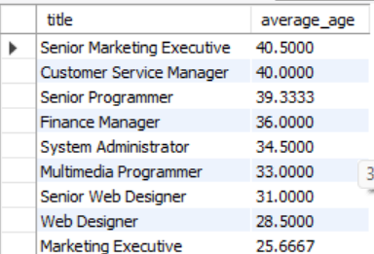

- Find and list the percentage perk (perk/salary X 100) for each employee with the % perks sorted in a descending order.
Answer: SELECT
f_name,
l_name,
salary,
perks,
(perks / salary) * 100 AS perk_percentage
FROM employee_data
ORDER BY perk_percentage DESC;

